**Name: Vijay vishnu p b**

**Roll No:49**

**Batch:mca b**

**Date:26-03-2022**

**OBJECT ORIENTED PROGRAMMING LAB**

**Experiment No.: 1**

**Aim**

Define a class ‘product’ with data members pcode, pname and price. create 3 objects of the class and find the product having the lowest price.

**Procedure**

public class Product{

String pcode, pname;

double price;

public void details(){

System.out.println("The product name is : "+pname);

System.out.println("The product code is : "+pcode);

System.out.println("The product price is : "+price);

System.out.println("\n");

}

public static void main(String[] args){

Product prod1= new Product();

prod1.pcode= "p1";

prod1.pname= "cocnut oil";

prod1.price= 55.7;

prod1.details();

Product prod2= new Product();

prod2.pcode= "p2";

prod2.pname= "Carrot";

prod2.price= 62.1;

prod2.details();

Product prod3= new Product();

prod3.pcode= "P3";

prod3.pname= "beans";

prod3.price= 5.0;

prod3.details();

System.out.println("\n");

if((prod1.price < prod2.price) && (prod1.price < prod3.price))

{

System.out.println("The price of "+prod1.pname+" is the lowest");

}

if((prod2.price<prod1.price)&&(prod2.price<prod3.price))

{

System.out.println("The price of "+prod2.pname+" is the lowest");

}

else{

System.out.println("The price of "+prod3.pname+" is the lowest");

}

}

}

**Output Screenshot**

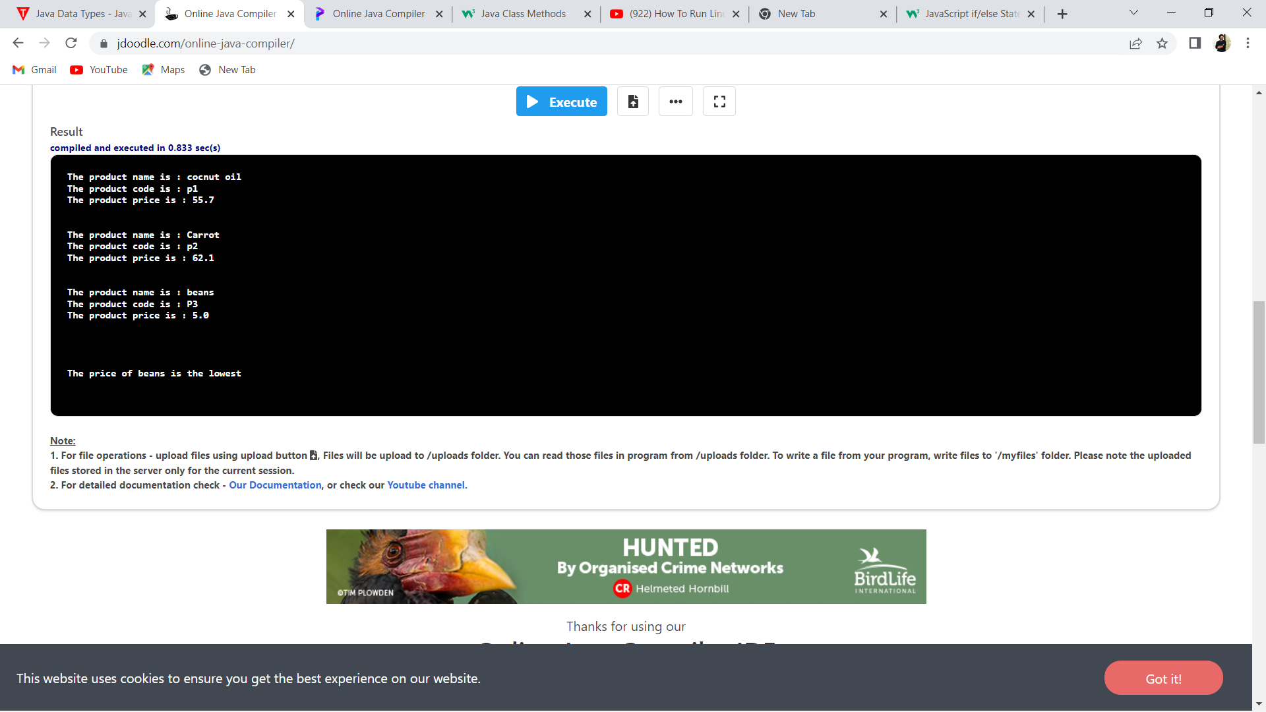

**Name: Vijay vishnu p b**

**Roll No:49**

**Batch:mca b**

**Date:06-04-2022**

**OBJECT ORIENTED PROGRAMMING LAB**

**Experiment No.: 2**

**Aim**

Read 2 matrices from the console and perform matrix addition.

**Procedure**

import java.util.*;

class MatrixAddition{

public static void main(String[] args){

int row, col;

Scanner sc= new Scanner(System.in);

System.out.print("Enter the number of rows for the Matrices : ");

row= sc.nextInt();

System.out.print("Enter the number of columns for the Matrices : ");

col= sc.nextInt();

int[][] matrixA= new int[row][col];

int[][] matrixB= new int[row][col];

int[][] matrixSum= new int[row][col];

System.out.println("Enter the elements for the Matrix A : ");

for(int i=0;i<row;i++){

for(int j=0;j<col;j++){

matrixA[i][j]= sc.nextInt();

}

}

System.out.println("\n");

System.out.println("Enter the elements for the Matrix B : ");

for(int i=0;i<row;i++){

for(int j=0;j<col;j++){

matrixB[i][j]= sc.nextInt();

}

}

System.out.println("\n");

System.out.println("Matrix A is : ");

for(int i=0;i<row;i++){

for(int j=0;j<col;j++){

System.out.print(matrixA[i][j]+" ");

}

System.out.println("\n");

}

System.out.println("Matrix B is : ");

for(int i=0;i<row;i++){

for(int j=0;j<col;j++){

System.out.print(matrixB[i][j]+" ");

}

System.out.println("\n");

}

for(int i=0;i<row;i++){

for(int j=0;j<col;j++){

matrixSum[i][j]= matrixA[i][j] + matrixB[i][j];

}

}

System.out.println("Resultant of the Matrix Addition is : ");

for(int i=0;i<row;i++){

for(int j=0;j<col;j++){

System.out.print(matrixSum[i][j]+" ");

}

System.out.println("\n");

}

}

}

**Output**

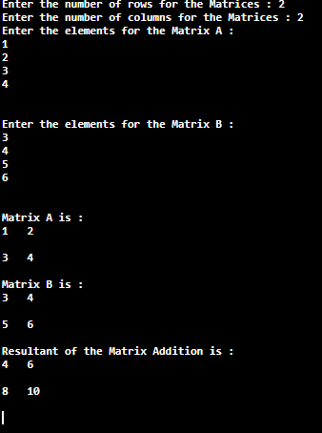

**Name: Vijay vishnu p b**

**Roll No:49**

**Batch:mca b**

**Date:6-04-2022**

**OBJECT ORIENTED PROGRAMMING LAB**

**Experiment No.: 3**

**Aim**

Add complex numbers

**Procedure**

import java.util.*;

public class ComplexNumber

{

public static void main(String args[])

{

double real1,real2,imag1,imag2;

Scanner sc=new Scanner(System.in);

System.out.println("\n Enter the real part of first complex number\n");

real1=sc.nextDouble();

System.out.println("\n Enter the imaginary part of the first complex number\n");

imag1=sc.nextDouble();

System.out.println("\n the first complex number you have entered is : "+real1+"+"+imag1+"i");

System.out.println("\n Enter the real part of second complex number\n");

real2=sc.nextDouble();

System.out.println("\n Enter the imaginary part of the second complex number\n");

imag2=sc.nextDouble();

System.out.println("\n The second complex number you have entered is : "+real2+imag2+"+"+"i");

double rsum=real1+real2;

double imagsum=imag1+imag2;

System.out.println("\n The sum of complex number 1 and complex number 2 is: "+rsum+"+"+imagsum+" i");

}

}

**Output**

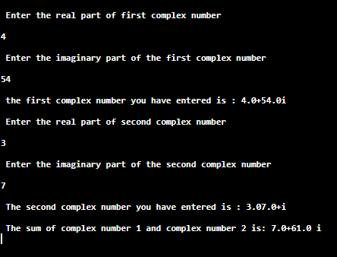

**Name: Vijay vishnu p b**

**Roll No:49**

**Batch:mca b**

**Date:6-04-2022**

**OBJECT ORIENTED PROGRAMMING LAB**

**Experiment No.: 4**

**Aim**

Read a matrix from the console and check whether it is symmetric or not

**Procedure**

import java.util.*;

class SymmetricMatrix{

public static void main(String[] args){

int row, col;

Scanner sc= new Scanner(System.in);

boolean isSymmetic= true;

System.out.print("Enter the number of rows for the Matrices : ");

row= sc.nextInt();

System.out.print("Enter the number of columns for the Matrices : ");

col= sc.nextInt();

int[][] matrix= new int[row][col];

System.out.println("Enter the elements for the Matrix : ");

for(int i=0;i<row;i++){

for(int j=0;j<col;j++){

matrix[i][j]= sc.nextInt();

}

}

System.out.println("\n");

System.out.println("The entered matrix is : ");

for(int i=0;i<row;i++){

for(int j=0;j<col;j++){

System.out.print(matrix[i][j]+" ");

}

System.out.println("\n");

}

for(int i=0;i<row;i++){

for(int j=0;j<col;j++){

if(i!=j){

if(matrix[i][j]!=matrix[j][i]){

isSymmetic= false;

break;

}}}

if(!isSymmetic)

break;

}

if(isSymmetic){

System.out.println("The entered matrix is Symmetric Matrix");

}

else{

System.out.println("The entered matrix is not a Symmetric Matrix");

}

}

}

**Output**

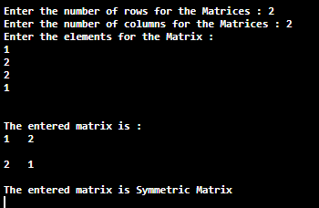

**Name: Vijay vishnu p b**

**Roll No:49**

**Batch:mca b**

**Date:6-04-2022**

**OBJECT ORIENTED PROGRAMMING LAB**

**Experiment No.: 5**

**Aim**

Create CPU with attribute price. Create inner class Processor (no. of cores, manufacturer) and static nested class RAM (memory, manufacturer). Create an object of CPU and print information of Processor and RAM.

**Procedure**

class CPU

{

int price=4000;

class PROCESSOR

{

int cores=4;

String manufactor="intel";

}

static class RAM

{

static int memory=16;

static String manufactor="dell";

}

}

public class innerc

{

public static void main(String args[])

{

CPU obj=new CPU();

CPU.PROCESSOR obj2=obj.new PROCESSOR();

System.out.println("-----displaying information----");

System.out.print("\n PRICE :"+obj.price);

System.out.print("\n CORES:"+obj2.cores);

System.out.print("\n manufactor:"+obj2.manufactor);

System.out.print("\n size of ram:"+CPU.RAM.memory);

System.out.print("\n ram manufactor:"+CPU.RAM.manufactor);

}

}

**Output Screenshot**

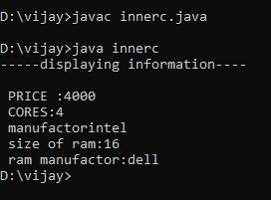

**Name: Vijay vishnu p b**

**Roll No:49**

**Batch:mca b**

**Date:22-04-2022**

**OBJECT ORIENTED PROGRAMMING LAB**

**Experiment No.: 6**

**Aim**

Program to Sort strings

**Procedure**

import java.util.Arrays;

import java.util.Scanner;

public class StringSort

{

   public static void main(String args[])

   {

      Scanner sc = new Scanner(System.in);

      System.out.println("Enter a string : \n");

      String str = sc.nextLine();

  System.out.println("\n Entered String is : "+str);

      char charArray[] = str.toCharArray();

      Arrays.sort(charArray);

      System.out.println("\n The sorted string is: "+new String(charArray));

   }

}

**Output**

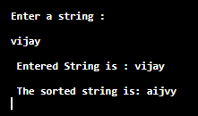

**Name: Vijay vishnu p b**

**Roll No:49**

**Batch:mca b**

**Date:22-04-2022**

**OBJECT ORIENTED PROGRAMMING LAB**

**Experiment No.: 7**

**Aim**

Program to search an array element

**Procedure**

import java.util.*;

public class search

{

public static void main(String [] args)

{

int a[] = new int [20]:

int size;

int number=0;

System.out.print("enter the size of array:");

Scanner sc= new Scanner(System.in);

size= sc.nextInt();

System.out.println("enter the array elements");

for(int i=0;i<size;i++)

{

a[i]= sc.nextInt();

}

System.out.println("the entered array elements are:");

for(int i=0;i<size;i++)

{

System.out.print(a[i] +"\t"); }

System.out.println("\n");

System.out.println("enter the no u want to search:");

number=sc.nextInt();

for(int i=0;i<size;i++)

{ if (a[i]==number)

{

System.out.println("the number"+number+" found at:"+i+" position");

}

}

}}

**Output Screenshot**

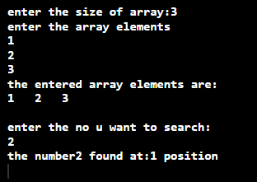

**Name: Vijay vishnu p b**

**Roll No:49**

**Batch:mca b**

**Date:13-05-2022**

**OBJECT ORIENTED PROGRAMMING LAB**

**Experiment No.: 8**

**Aim**

Program to perorme string manipulation.

**Procedure**

import java.util.*;

class StringManip

{

String s1;

String s2;

int len;

Scanner sc=new Scanner(System.in);

String concat_string(String str1,String str2)

{

return str1.concat(str2);

}

int countLength(String str1)

{

return str1.length();

}

String caseConvert(String str1)

{

if(str1.equals(str1.toUpperCase()))

return str1.toLowerCase();

else

return str1.toUpperCase();

}

String replaceSubstring(String str1,String str2,String str3)

{

return str1.replace(str3,str2);

}

String sortString(String str1)

{

char[] a=new char[str1.length()];

a=str1.toCharArray();

Arrays.sort(a);

str1=new String(a);

return str1;

}

int returnCharPos(String str1,char ch)

{

return str1.indexOf(ch);

}

}

public class StringManipulation

{

public static void main(String args[])

{

StringManip ob=new StringManip();

int opt;

String str1,str2,str3;

char ch;

Scanner sc=new Scanner(System.in);

do

{

System.out.println("\n 1. FIND AN INDEX OF A CHARACTER IN A STRING\n");

System.out.println("\n 2. CONCATENATE TWO STRINGS\n");

System.out.println("\n 3. REPLACE A SUBSTRING\n");

System.out.println("\n 4. SEE THE LENGTH OF A STRING\n");

System.out.println("\n 5. CONVERT THE CASE OF STRING\n");

System.out.println("\n 6. EXIT\n");

opt=sc.nextInt();

switch(opt)

{

case 1: sc.nextLine();

System.out.println("\n Enter a string : \n");

str1=sc.nextLine();

System.out.println("\n Enter a character to be searched: ");

ch=sc.next().charAt(0);

System.out.println("\n The character "+ch+" found at "+ob.returnCharPos(str1,ch)+" in the string "+str1);

break;

case 2: sc.nextLine();

System.out.println("\n Enter string 1: \n");

str1=sc.nextLine();

System.out.println("\n Enter string 2: \n");

str2=sc.nextLine();

System.out.println("\n After concatenating the above string, we get "+ob.concat_string(str1,str2));

break;

case 3: sc.nextLine();

System.out.println("\n Enter a string : ");

str1=sc.nextLine();

System.out.println("\n Enter a word: ");

str2=sc.nextLine();

System.out.println("\n Enter a substring : ");

str3=sc.nextLine();

if(str1.contains(str3))

System.out.println("\n Replacing "+str3+" with the word "+str2+" and the result is : "+ob.replaceSubstring(str1,str2,str3));

else

System.out.println("\n Substring do not match !!!\n");

break;

case 4: sc.nextLine();

System.out.println("\n Enter a string : ");

str1=sc.nextLine();

System.out.println("\n The length of the string is : "+ob.countLength(str1));

break;

case 5: sc.nextLine();

System.out.println("\n Enter a string to be converted: (Enter either in capital or not)");

str2=sc.nextLine();

if(str2.equals(str2.toUpperCase())==false && str2.equals(str2.toLowerCase())==false)

System.out.println("\n Enter in correct format\n");

System.out.println("\n The converted string is : "+ob.caseConvert(str2));

break;

case 6: System.exit(0);

default: System.out.println("\n INVALID CHOICE !!!\n");

}

}

while(opt!=6);

}

}

**Output Screenshot**

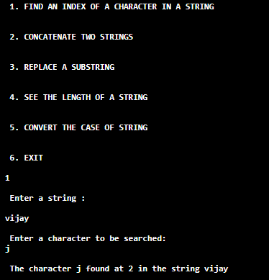

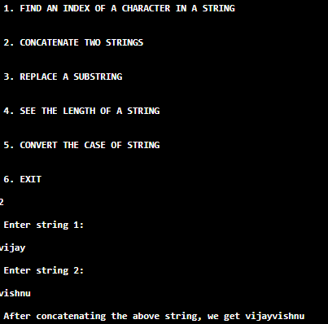

**Name: Vijay vishnu p b**

**Roll No:49**

**Batch:mca b**

**Date:13-05-2022**

**OBJECT ORIENTED PROGRAMMING LAB**

**Experiment No.: 9**

**Aim**

Program to create a class for Employee having attributes eNo, eName eSalary.

Read n employ information and Search for an employee given eNo, using the concept of Array of Objects.

**Procedure**

import java.util.*;

public class Employee

{

Scanner sc=new Scanner(System.in);

int eNo;

String eName;

int eSal;

void read_emp()

{

System.out.println("\n Enter employee number: ");

eNo=sc.nextInt();

sc.nextLine();

System.out.println("\n Enter employee name: ");

eName=new String(sc.nextLine());

System.out.println("\n Enter salary of employee: ");

eSal=sc.nextInt();

}

void print_emp()

{

System.out.println("\n Employee Information\n");

System.out.println("\n EMPLOYEE NO. : "+eNo);

System.out.println("\n EMPLOYEE NAME: "+eName);

System.out.println("\n SALARY : "+eSal);

}

public static void main(String[] args)

{

int n,i,key;

int opt;

Scanner sc=new Scanner(System.in);

System.out.println("\n How many records you have to save\n");

n=sc.nextInt();

Employee ob[]=new Employee[n];

for(i=0;i<n;i++)

{

ob[i]=new Employee();

System.out.println("\n ENTER DETAILS OF EMPLOYEE "+(i+1));

ob[i].read_emp();

}

do

{

System.out.println("\n Enter an employee number to be searched: ");

key=sc.nextInt();

if(key>=1 && key<=n)

{

for(i=0;i<n;i++)

{

if(ob[i].eNo==key)

break;

else

continue;

}

System.out.println("\n INFORMATION OF EMPLOYEE   HAVING EMPLOYEE NUMBER "+ob[i].eNo);

ob[i].print_emp();

}

else

{

System.out.println("\n Record Not Found!!!Error.....");

}

System.out.println("\n Do you want to visit anymore records ? (1 for yes , 0    for No)");

opt=sc.nextInt();

}

while(opt!=0);

}

}

**Output Screenshot**

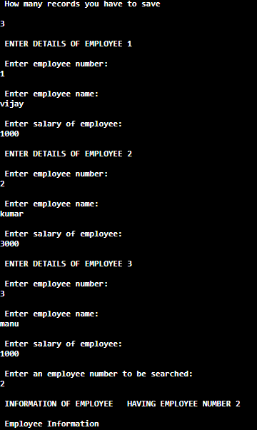

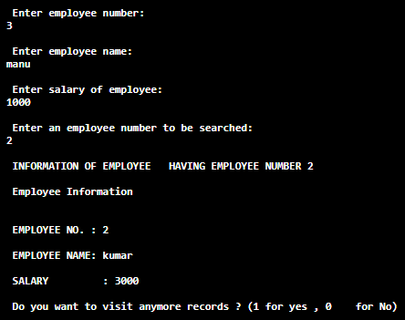

**Name: Vijay vishnu p b**

**Roll No:49**

**Batch:mca b**

**Date:17-05-2022**

**OBJECT ORIENTED PROGRAMMING LAB**

**Experiment No.: 10**

**Aim**

To demonstrate the use of method overloading by finding the area of different shapes

**Procedure**

import java.util.Scanner;

class Shape

{

double l,b,h,r,w;

double area;

int flag;

Shape(double l,double b,double h,double w,double r)

{

this.l=l;

this.b=b;

this.h=h;

this.w=w;

this.r=r;

}

void find_area(double l,double b)

{

area=(l*b);

}

void find_area(double r)

{

area= (3.14*r*r);

}

void find_area(int flag,double w, double h)

{

if(flag==1)

area=(0.5*w*h);

else

area=0;

}

void display()

{

System.out.println("\n DETAILS OF CIRCLE\n");

System.out.println("\n RADIUS : "+r);

System.out.println("\n AREA   : "+area);

System.out.println("\n--------------------\n");

System.out.println("\n DETAILS OF RECTANGLE\n");

System.out.println("\n LENGTH : "+l);

System.out.println("\n BREADTH  : "+b);

System.out.println("\n AREA : "+area);

System.out.println("\n----------------------\n");

System.out.println("\n DETAILS OF TRIANGLE\n");

System.out.println("\n BREADTH : "+w);

System.out.println("\n HEIGHT   : "+h);

System.out.println("\n AREA : "+area);

}

}

public class OverloadingSample

{

public static void main(String arg[])

{

Scanner sc=new Scanner(System.in);

double l,b,r,w,h;

int flag=1;

System.out.println("\n Enter the length and breadth of rectangle: ");

l=sc.nextDouble();

b=sc.nextDouble();

System.out.println("\n Enter the radius of the circle : ");

r=sc.nextDouble();

System.out.println("\n Enter the height and breadth of the triangle: ");

h=sc.nextDouble();

w=sc.nextDouble();

Shape ob1=new Shape(l,b,h,w,r);

ob1.find_area(r);

ob1.find_area(l,b);

ob1.find_area(flag,w,h);

System.out.println("\n INFORMATION OF ALL SHAPES \n");

ob1.display();}}

**Output Screensho**

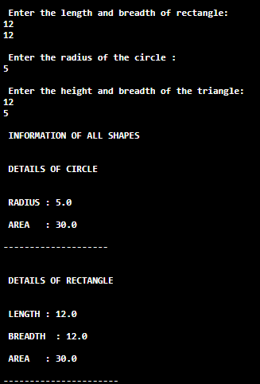 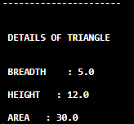

**Name: Vijay vishnu p b**

**Roll No:49**

**Batch:mca b**

**Date:17-05-2022**

**OBJECT ORIENTED PROGRAMMING LAB**

**Experiment No.: 11**

**Aim**

Create a class ‘Employee’ with data members Empid, Name, Salary, Address and

constructors to initialize the data members. Create another class ‘Teacher’ that inherit the

properties of class employee and contain its own data members department, Subjects taught

and constructors to initialize these data members and also include display function to

display all the data members. Use array of objects to display details of N teachers.

**Procedure**

import java.util.Scanner;

class Employee

{

int EmpId;

String EmpName;

double Salary;

String Address;

Employee(int empid,String empname,double salary,String address)

{

EmpId=empid;

EmpName=empname;

Salary=salary;

Address=address;

}

}

class Teacher extends Employee

{

String deptname,subject;

Teacher(int empid,String empname,double salary,String address,String deptname,String subject)

{

super(empid,empname,salary,address);

this.deptname=deptname;

this.subject=subject;

}

void display()

{

System.out.println("\n EMPLOYEE INFORMATION\n");

System.out.println("\n EMPLOYEE ID : "+EmpId);

System.out.println("\n NAME : "+EmpName);

System.out.println("\n ADDRESS : "+Address);

System.out.println("\n SALARY : "+Salary);

System.out.println("\n DEPARTMENT   : "+deptname);

System.out.println("\n SUBJECT TAUGHT : "+subject);

}

}

public class InheritanceSample

{

public static void main(String args[])

{

Scanner sc=new Scanner(System.in);

String empname,address;

double salary;

int empid;

int i,n;

String dept,subject;

Teacher[] ob;

System.out.println("\n How many records you want to insert  ? ");

n=sc.nextInt();

ob=new Teacher[n];

System.out.println("\n Enter details of "+n+" employees \n");

for(i=0;i<n;i++)

{

System.out.println("\n ENTER ID OF EMPLOYEE "+(i+1)+":");

empid=sc.nextInt();

sc.nextLine();

System.out.println("\n ENTER NAME OF THE EMPLOYEE : "+(i+1)+":");

empname=sc.nextLine();

System.out.println("\n ENTER ADDRESS OF EMPLOYEE "+(i+1)+":");

address=sc.nextLine();

System.out.println("\n ENTER THE SALARY OF EMPLOYEE "+(i+1)+":");

salary=sc.nextDouble();

sc.nextLine();

System.out.println("\n ENTER THE DEPARTMENT OF THE EMPLOYEE: ");

dept=sc.nextLine();

System.out.println("\n ENTER THE SUBJECT TAUGHT BY THE EMPLOYEE(TEACHER): ");

subject=sc.nextLine();

ob[i]=new Teacher(empid,empname,salary,address,dept,subject);

}

System.out.println("\n INFORMATION OF ALL EMPLOYEES\n");

for(i=0;i<n;i++)

ob[i].display();

}

}

**Output Screenshot**

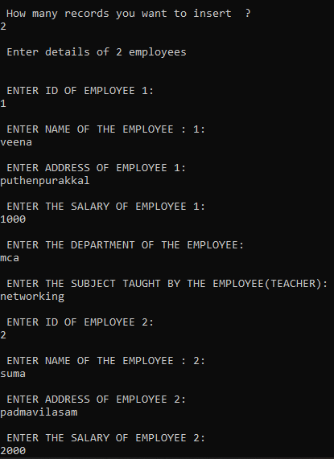

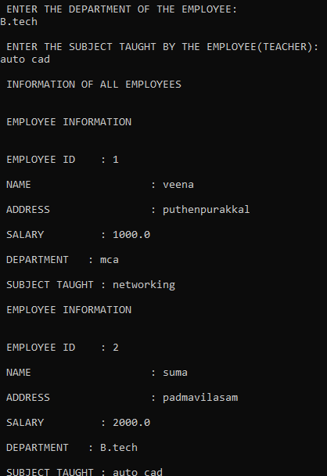

OBJECT ORIENTED PROGRAMMING LAB

**Name: Vijay Vishnu p b**

**Roll No:49**

**Batch:B**

**Date:18-05-22**

**Experiment No.: 12**

**Aim**

To demonstrate the use of multi-level inheritance along with method overloading

**Procedure**

import java.io.*;

import java.lang.*;

class Person

{

String empname;

String gender,address;

int age;

Person(String empname,String gender,String address,int age)

{

this.empname=empname;

this.gender=gender;

this.address=address;

this.age=age;

}

}

class Employee extends Person

{

int empid;

String company_name;

String qualification;

int salary;

Employee(String empname,String gender,String address,int age,int empid,String company_name,String qualification,int salary)

{

super(empname,gender,address,age);

this.empid=empid;

this.company_name=company_name;

this.qualification=qualification;

this.salary=salary;

}

}

class Teacher extends Employee

{

int teacherid;

String dept,subject;

Teacher(String empname,String gender,String address,int age,int empid,String company_name,String qualification,int salary,int teacherid,String dept,String subject)

{

super(empname,gender,address,empid,age,company_name,qualification,salary);

this.teacherid=teacherid;

this.dept=dept;

this.subject=subject;

}

void display()

{

System.out.println("\n EMPLOYEE ID : "+empid);

System.out.println("\n EMPLOYEE NAME : "+empname);

System.out.println("\n AGE OF THE EMPLOYEE : "+age);

System.out.println("\n GENDER : "+gender);

System.out.println("\n ADDRESS : "+address);

System.out.println("\n QUALIFICATION : "+qualification);

System.out.println("\n COMPANY NAME : "+company_name);

System.out.println("\n TEACHER ID : "+teacherid);

System.out.println("\n DEPARTMENT : "+dept);

System.out.println("\n SUBJECT TAKEN : "+subject);

System.out.println("\n SALARY : "+salary);

}

}

public class InheritanceOfThree

{

public static void main(String[] args)

{

int i,n;

int age,salary,empid;

int teacherid;

String empname,dept,company_name,subject,address,qualification,gender;

BufferedReader br=new BufferedReader(new InputStreamReader(System.in));

try

{

System.out.println("\n How much records you need to insert ? ");

n=Integer.parseInt(br.readLine());

Teacher ob1[]=new Teacher[n];

i=0;

while(i<n)

{

System.out.println("\n Enter details of teacher "+(i+1)+":\n");

System.out.println("\n Enter employee id : ");

empid=Integer.parseInt(br.readLine());

System.out.println("\n Enter teacher id: ");

teacherid=Integer.parseInt(br.readLine());

System.out.println("\n Enter name of teacher : ");

empname=br.readLine();

System.out.println("\n Enter age : ");

age=Integer.parseInt(br.readLine());

System.out.println("\n Enter gender : ");

gender=br.readLine();

System.out.println("\n Enter qualification: ");

qualification=br.readLine();

System.out.println("\n Enter subject name : ");

subject=br.readLine();

System.out.println("\n Enter the company name : ");

company_name=br.readLine();

System.out.println("\n Enter the residential address: ");

address=br.readLine();

System.out.println("\n Enter the name of the department: ");

dept=br.readLine();

System.out.println("\n Enter salary: ");

salary=Integer.parseInt(br.readLine());

ob1[i]=new Teacher(empname,gender,address,empid,age,company_name,qualification,salary,teacherid,dept,subject);

i++;

}

System.out.println("\n TEACHER'S INFORMATION\n");

for(i=0;i<n;i++)

{

ob1[i].display();

}

}

catch(Exception e)

{

}

}}

**Output Screenshot**

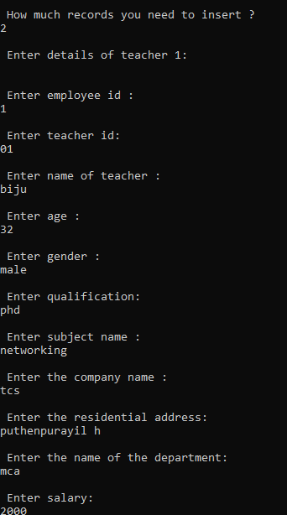

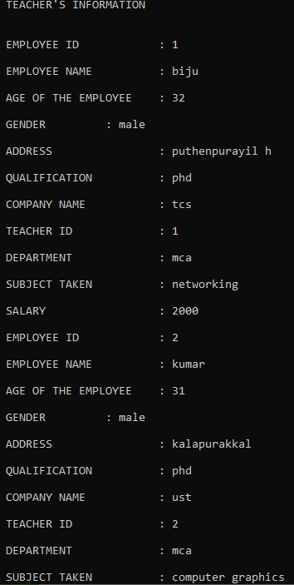

**Name: Vijay vishnu p b**

**Roll No:49**

**Batch:mca b**

**Date:18-05-2022**

**OBJECT ORIENTED PROGRAMMING LAB**

**Experiment No.: 13**

**Aim**

Write a program has class Publisher, Book, Literature and Fiction. Read the information and print the details of books from either the category, using inheritance.

**Procedure**

import java.io.*;

class Publisher

{

int pid;

String pname;

Publisher(int pid,String pname)

{

this.pid=pid;

this.pname=pname;

}

}

class Book extends Publisher

{

int bid;

String title;

String author;

int price;

int nop;

Book(int pid,String pname,int bid,String title,int price,int nop,String author)

{

super(pid,pname);

this.bid=bid;

this.title=title;

this.price=price;

this.nop=nop;

this.author=author;

}

}

class Literature extends Book

{

String language;

int rating;

int year;

Literature(int pid,String pname,int bid,String title,int price,int nop,String author,String language,int rating,int year)

{

super(pid,pname,bid,title,price,nop,author);

this.language=language;

this.rating=rating;

this.year=year;

}

void display()

{

System.out.println("\n PUBLISHER ID : "+pid);

System.out.println("\n PUBLISHER : "+pname);

System.out.println("\n BOOK ID : "+bid);

System.out.println("\n TITLE : "+title);

System.out.println("\n PRICE : "+price);

System.out.println("\n NO. OF PAGES : "+nop);

System.out.println("\n LANGUAGE : "+language);

System.out.println("\n AUTHOR : "+author);

System.out.println("\n RATING : "+rating);

System.out.println("\n YEAR OF PUBLISHING : "+year);

}

}

class Fiction extends Book

{

String category;

String type;

int year;

Fiction(int pid,String pname,int bid,String title,int price,int nop,String author,String category,String type,int year)

{

super(pid,pname,bid,title,price,nop,author);

this.category=category;

this.type=type;

this.year=year;

}

void display()

{

System.out.println("\n PUBLISHER ID : "+pid);

System.out.println("\n PUBLISHER : "+pname);

System.out.println("\n BOOK ID : "+bid);

System.out.println("\n TITLE : "+title);

System.out.println("\n PRICE : "+price);

System.out.println("\n NO. OF PAGES : "+nop);

System.out.println("\n AUTHOR : "+author);

System.out.println("\n CATEGORY : "+category);

System.out.println("\n TYPE / THEME : "+type);

System.out.println("\n YEAR OF PUBLISHING :"+year);

}

}

public class DetailOfBook

{

public static void main(String[] args)

{

BufferedReader br=new BufferedReader(new InputStreamReader(System.in));

int opt;

int pid=0,price=0,bid=0,nop=0,year=0,rating=0;

String pname="",title="",category="",type="",language="",author="";

try

{

do

{

System.out.println("\n SELECT AN OPTION\n");

System.out.println("\n 1. I WANT TO ENTER A RECORD OF A LITERATURE\n");

System.out.println("\n 2. I WANT TO ENTER A RECORD OF A FICTION\n");

System.out.println("\n 3. I WANT TO EXIT\n");

opt=Integer.parseInt(br.readLine());

if(opt==1 || opt==2)

{

System.out.println("\n Please fill the following \n");

System.out.println("\n Enter publisher id : \n");

pid=Integer.parseInt(br.readLine());

System.out.println("\n Enter the publisher's name:\n");

pname=br.readLine();

System.out.println("\n Enter the ID of the book : \n");

bid=Integer.parseInt(br.readLine());

System.out.println("\n Enter the title of the book : \n");

title=br.readLine();

System.out.println("\n Enter the price \n");

price=Integer.parseInt(br.readLine());

System.out.println("\n How many pages are of this book ? \n");

nop=Integer.parseInt(br.readLine());

System.out.println("\n Enter the name of author: \n");

author=br.readLine();

}

switch(opt)

{

case 1: System.out.println("\n Enter the language of the book \n");

language=br.readLine();

System.out.println("\n Enter a rating \n");

rating=Integer.parseInt(br.readLine());

System.out.println("\n Enter year of publishing: \n");

year=Integer.parseInt(br.readLine());

break;

case 2: System.out.println("\n Enter the category of the book ? \n");

category=br.readLine();

System.out.println("\n Enter the theme of the content \n");

type=br.readLine();

System.out.println("\n Enter year of publishing: \n");

year=Integer.parseInt(br.readLine());

break;

case 3: System.exit(0);

default: System.out.println("\n Invalid Option\n");

}

if(opt==1)

{

Literature ob1=new Literature(pid,pname,bid,title,price,nop,author,language,rating,year);

ob1.display();

}

else

{

Fiction ob2=new Fiction(pid,pname,bid,title,price,nop,author,category,type,year);

ob2.display();

}

}

while(opt!=3);

}

catch(Exception e)

{

}}}

**Output Screenshot**

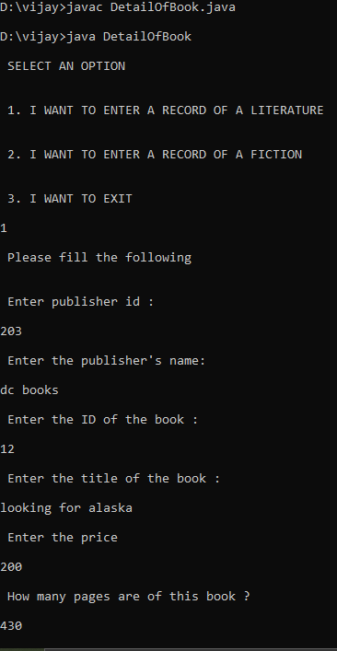

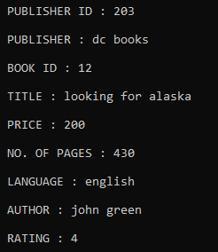

OBJECT ORIENTED PROGRAMMING LAB

**Name: Vijay Vishnu p b**

**Roll No:49**

**Batch: B**

**Date: 18-05-22**

**Experiment No.: 14**

**Aim**

Create classes Student and Sports(inherited from Student). Create another class Result inherited from Sports. Display the academic and sports score of a student.

**Procedure**

import java.io.*;

class Student

{

int id;

String name;

String course;

int age;

Student(int id,String name,String course,int age)

{

this.id=id;

this.name=name;

this.course=course;

this.age=age;

}

}

class Sports extends Student

{

String item;

int item_code;

double height,weight;

Sports(int id,String name,String course,int age,String item,int item_code,double height,double weight)

{

super(id,name,course,age);

this.item=item;

this.item_code=item_code;

this.height=height;

this.weight=weight;

}

}

class Result extends Sports

{

int m1,m2,m3;

int mark,smark;

String result;

Result(int id,String name,String course,int age,String item,int item_code,double height,double weight)

{

super(id,name,course,age,item,item_code,height,weight);

}

void get_data()

{

BufferedReader br=new BufferedReader(new InputStreamReader(System.in));

try

{

System.out.println("\n Enter the marks of three subjects:\n");

m1=Integer.parseInt(br.readLine());

m2=Integer.parseInt(br.readLine());

m3=Integer.parseInt(br.readLine());

System.out.println("\n Enter the point got in "+item+": ");

smark=Integer.parseInt(br.readLine());

mark=m1+m2+m3;

}

catch(Exception e)

{

}

}

void display()

{

System.out.println("\n RESULT SUMMARY\n");

System.out.println("\n ID : "+id);

System.out.println("\n NAME : "+name);

System.out.println("\n AGE : "+age);

System.out.println("\n COURSE: "+course);

System.out.println("\n SPORTS ITEM: "+item);

System.out.println("\n ITEM CODE : "+item_code);

System.out.println("\n HEIGHT : "+height);

System.out.println("\n WEIGHT : "+weight);

System.out.println("\n POINTS IN "+item+": "+smark);

}

}

public class ResultSummary

{

public static void main(String args[])

{

BufferedReader br=new BufferedReader(new InputStreamReader(System.in));

int id,age;

String name,course;

String item;

int item_code;

double height,weight;

try

{

System.out.println("\n Enter the id: \n");

id=Integer.parseInt(br.readLine());

System.out.println("\n Enter the name : ");

name=br.readLine();

System.out.println("\n Enter the course: ");

course=br.readLine();

System.out.println("\n Enter the age : ");

age=Integer.parseInt(br.readLine());

System.out.println("\n Enter the item code : ");

item_code=Integer.parseInt(br.readLine());

System.out.println("\n Enter the sports item: ");

item=br.readLine();

System.out.println("\n Enter the height : ");

height=Double.parseDouble(br.readLine());

System.out.println("\n Enter the weight : ");

weight=Double.parseDouble(br.readLine());

Result r=new Result(id,name,course,age,item,item_code,height,weight);

r.get_data();

r.display();

}

catch(Exception e)

{

}

}

}

**Output Screenshot**

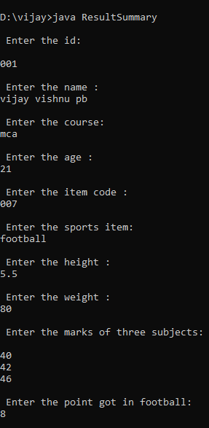

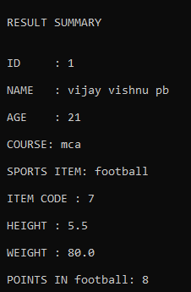

OBJECT ORIENTED PROGRAMMING LAB

**Name: ViJAY VISHNU PB**

**Roll No: 59**

**Batch: B**

**Date: 24-05-22**

**Experiment No.: 15**

**Aim**

Create an interface having prototypes of functions area() and perimeter(). Create two classes Circle and Rectangle which implements the above interface. Create a menu driven program to find area and perimeter of objects

**Procedure**

import java.io.*;

interface AreaAndPerimeter

{

double area();

double peri();

}

class Circle implements AreaAndPerimeter

{

double r;

Circle(double r)

{

this.r=r;

}

public double area()

{

return 3.14*r*r;

}

public double peri()

{

return 2*3.14*r;

}

}

class Rectangle implements AreaAndPerimeter

{

double l,b;

Rectangle(double l,double b)

{

this.l=l;

this.b=b;

}

public double area()

{

return l*b;

}

public double peri()

{

return 2*(l+b);

}

}

public class InterfaceShapes

{

public static void main(String args[])

{

double r=0,l=0,b=0;

int opt;

BufferedReader br=new BufferedReader(new InputStreamReader(System.in));

try

{

do

{

System.out.println("\n Enter a choice \n");

System.out.println("\n 1. CIRCLE\n");

System.out.println("\n 2. RECTANGLE\n");

System.out.println("\n 3. EXIT\n");

opt=Integer.parseInt(br.readLine());

if(opt==1)

{

System.out.println("\n Enter the radius of the circle\n");

r=Double.parseDouble(br.readLine());

Circle c1=new Circle(r);

c1.area();

System.out.println("\n Perimeter of the circle: "+c1.peri());

System.out.println("\n area of the circle: "+c1.area());

}

if(opt==2)

{

System.out.println("\n Enter the length and breadth of the rectangle\n");

l=Double.parseDouble(br.readLine());

b=Double.parseDouble(br.readLine());

Rectangle r1=new Rectangle(l,b);

System.out.println("\n Area of the rectangle : "+r1.area());

System.out.println("\n Perimeter of the rectangle: "+r1.peri());

}

}

while(opt!=3);

}

catch(Exception e)

{

}

}}

**Output Screenshot**

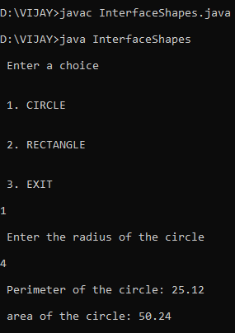

|  |
| --- |
| **Name : vijay vishnu p b**  **Roll No : 49**  **Batch : B**  **Date : 24-05-22** |

**OBJECT ORIENTED PROGRAMING LAB**

**Experiment No.: 16**

**AIM:**

Prepare a bill using calculate method from interface.

**Source Code**

import java.util.Scanner;

interface calc{

void calculate();

}

class bill implements calc{

String date,name,p_id;

int quantity;

double unit_price,total,namount=0;

Scanner sc = new Scanner(System.in);

public void getdata(){

System.out.println("\nEnter the product id : ");

p_id = sc.nextLine();

System.out.println("Enter the product name : ");

name = sc.nextLine();

System.out.println("Enter the Quantity : ");

quantity = sc.nextInt();

System.out.println("Enter the unit price : ");

unit_price = sc.nextDouble();

}

public void calculate(){

total = quantity * unit_price;

}

public void display(){

System.out.println(p_id+"\t\t"+name+"\t\t"+quantity+"\t\t"+unit_price+"\t"+total);

}

}

public class Product{

public static void main(String[] args){

int n,i;

double namount=0,t;

int ran;

String date;

t = Math.random() *1000000;

ran = (int) t;

Scanner sc = new Scanner(System.in);

System.out.println("Order no. #"+ran);

System.out.println("Enter the date:");

date = sc.nextLine();

System.out.println("Enter the number of products : ");

n = sc.nextInt();

bill ob[] = new bill[n];

for(i=0;i<n;i++)

ob[i] = new bill();

for(i=0;i<n;i++){

ob[i].getdata();

ob[i].calculate();

}

System.out.println("Date:"+date);

System.out.println("Product Id \tName\t Quantity\t unit price\t Total ");

System.out.println("--------------------------------------------------------------");

for(i=0;i<n;i++){

ob[i].display();

namount += ob[i].total;

}

System.out.println("--------------------------------------------------------------");

System.out.println("\t\t\tNet.Amount\t"+ namount);

}

}

**Output Screenshot**

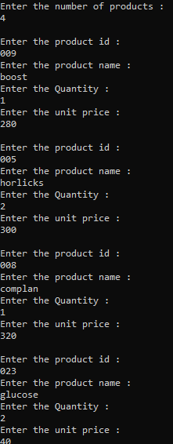

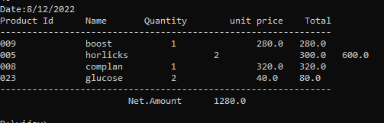

**Name: Vijay vishnu p b**

**Roll No:49**

**Batch:mca b**

**Date:31-05-2022**

**OBJECT ORIENTED PROGRAMMING LAB**

**Experiment No.: 17**

**Aim**

Create a Graphics package that has classes and interfaces for figures Rectangle, Triangle,

Square and Circle. Test the package by finding the area of these figures.

**Procedure**

package graphics;

interface interface_graphics{

public float recArea(int l, int h);

public float cirArea(int r);

public float squArea(int a);

public float triArea(int l, int h);

}

public class package_graphics implements interface_graphics {

public float recArea(int l, int h){

return l*h;

}

public float cirArea(int r){

return r*r*(float)3.14;

}

public float squArea(int a){

return a*a;

}

public float triArea(int l, int h){

return l*h*(float)(.5);

}

}

import graphics.*;

public class main_graphics {

public static void main(String []args){

package_graphics testObj = new package_graphics();

System.out.println("the area of the rectangle is:"+testObj.recArea(11,23));

System.out.println("the area of circle is:"+testObj.cirArea(5));

System.out.println("the area of square is:"+testObj.squArea(25));

System.out.println("the area of triangle is: "+testObj.triArea(11,6));

}

}

**Output Screenshot**

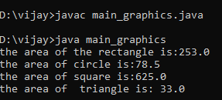

**Name: Vijay vishnu p b**

**Roll No:49**

**Batch:mca b**

**Date:31-05-2022**

**OBJECT ORIENTED PROGRAMMING LAB**

**Experiment No.: 18**

**Aim**

Write a user defined exception class to authenticate the user name and password.

**Procedure**

import authent.*;

import java.util.Scanner;

public class authentication {

public static void main(String[] args)

{

String username = "vijay";

String password = "vortex";

Scanner sc = new Scanner(System.in);

System.out.println("Enter the Username");

String u1 = sc.nextLine();

System.out.println("Enter the Password");

String u2 = sc.nextLine();

try

{

if ((u1.equals(username)) && (u2.equals(password)))

{

System.out.println("Acess Granted");

}

else

{

throw new credentialexception("Invalid Credentials");

}

}

catch (credentialexception e)

{

System.out.println(e.getMessage());

}

}

}

package authent;

public class credentialexception extends Exception

{

public credentialexception(String s)

{

super(s);

}

}

**Output Screenshot**

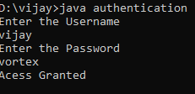

**Name: Vijay vishnu p b**

**Roll No:49**

**Batch:mca b**

**Date:1-06-2022**

**OBJECT ORIENTED PROGRAMMING LAB**

**Experiment No.: 19**

**Aim**

Find the average of N positive integers, raising a user defined exception for each negative input.

**Procedure**

import java.util.Scanner;

public class IntegerNum{

public static class InvalidNumberException extends Exception {

public InvalidNumberException() {

super("Please provide a valid number!");

}

}

public static void main(String [] args){

Scanner sc=new Scanner(System.in);

int c,num,sum=0;

double avg;

System.out.println("enter the count:");

c=sc.nextInt();

System.out.println("enter the Numbers:");

for(int i=0;i<c;i++){

try{

num=sc.nextInt();

if(num>0){

sum+=num;

}else{

i--;

throw new InvalidNumberException();

}

}

catch(InvalidNumberException e){

System.out.println(e.getMessage());

}

}

System.out.println("sum is"+sum);

System.out.println("avg is"+sum/c);

}

}

**Output Screenshot**

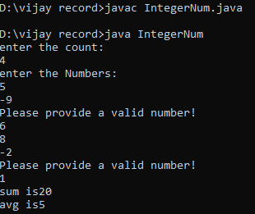

**Name: Vijay vishnu p b**

**Roll No:49**

**Batch:mca b**

**Date:1-06-2022**

**OBJECT ORIENTED PROGRAMMING LAB**

**Experiment No.: 20**

**Aim**

Define 2 classes; one for generating Fibonacci numbers and other for displaying even numbers in a given range. Implement using threads. (Runnable Interface).

**Procedure**

import java.util.*;

class fibonacci implements Runnable {

int l;

fibonacci(int n) {

l = n;

}

public void run() {

int c;

int a = 0, b = 1;

System.out.print("Fibonacci:");

System.out.print(a + " " + b);

for (int i = 0; i <= l; i++) {

c = a + b;

System.out.print(" " + c);

a = b;

b = c;

}

}

}

class even implements Runnable {

int l;

even(int n) {

l = n;

}

public void run() {

System.out.print("Even Number:");

for (int i = 0; i <= l; i++) {

if (i % 2 == 0)

System.out.print(i + " ");

}

System.out.println("");

}

}

class Numbers{

public static void main(String args[]) {

Scanner sc = new Scanner(System.in);

System.out.println("Enter Limit :");

int l = sc.nextInt();

even e = new even(l);

Thread T2 = new Thread(e);

T2.start();

fibonacci f = new fibonacci(l);

Thread T1 = new Thread(f);

T1.start();

}

}

**Output Screenshot**

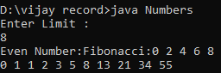

**Name: Vijay vishnu p b**

**Roll No:49**

**Batch:mca b**

**Date:1-06-2022**

**OBJECT ORIENTED PROGRAMMING LAB**

**Experiment No.: 21**

**Aim**

Program to create a generic stack and do the Push and Pop operations.

**Procedure**

import java.util.*;

class operations{

public void operation()

{

int top =-1,ch,n,e;

Scanner inp = new Scanner(System.in);

System.out.println("Enter Size of Stack");

n = inp.nextInt();

int size=n-1;

int[] arr = new int[n];

do {

System.out.println("\n=============\n MENU : \n1.push \n2.pop \n3.Display \n4.Exit \n=============");

System.out.println("Enter your choice");

ch = inp.nextInt();

switch(ch)

{

case 1 :

if(top == size)

{

System.out.println(" *** Stack is Full *** ");

}

else

{

System.out.println("Enter Element : ");

e = inp.nextInt();

top++;

arr[top] =e;

}

break;

case 2 :

if(top == -1)

{

System.out.println("\n*** Stack is empty *** ");

}

else

{

System.out.println("\n"+ arr[top] + " is removed ");

top--;

}

break;

case 3 :

if(top == -1)

{

System.out.println(" *** Stack is empty ***");

}

else

{

System.out.println("\n*** Stack : ***\n");

for(int i=top;i>=0;i--)

{

System.out.println(" " +arr[i]);

System.out.println("-----");

}

}

break;

case 4 :

System.exit(0);

default : System.out.println("Invalid Choice");

}

}while(ch !=4);

}

}

public class Stackopertaion{

public static void main(String[] args) {

operations obj = new operations();

obj.operation();

}

}

**Output Screenshot**

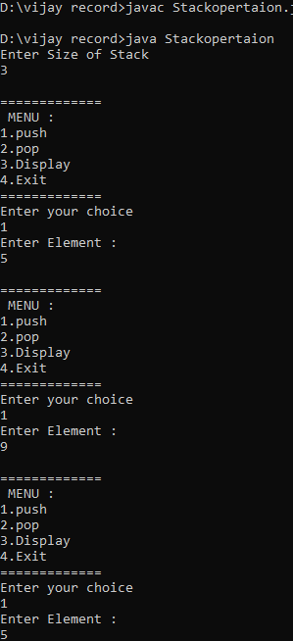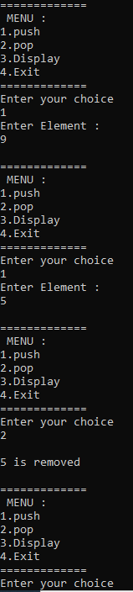

**Name: Vijay vishnu p b**

**Roll No:49**

**Batch:mca b**

**Date:7-06-2022**

**OBJECT ORIENTED PROGRAMMING LAB**

**Experiment No.: 22**

**Aim**

Maintain a list of Strings using ArrayList from collection framework, perform built-in Operations

**Procedure**

import java.util.*;

public class arraylist{

public static void main(String[] args) {

ArrayList<String> arrayList= new ArrayList<>();

arrayList.add("vijay");

arrayList.add("chilli");

arrayList.add("hector");

arrayList.add("watson");

System.out.println("The elements of the arraylist is - "+arrayList);

Collections.sort(arrayList);

System.out.println("\nThe ArrayList Sort : "+arrayList);

Collections.addAll(arrayList,"manu","Vortex","Shantanu","wanner","escobar");

System.out.println("\nAdding new items in the arraylist is : "+arrayList);

Collections.sort(arrayList, Collections.reverseOrder());

System.out.println("\nThe reverse order of the arraylist : "+arrayList);

System.out.println("\nThe maximum element of the arraylist : "+Collections.max(arrayList));

}

}

**Output Screenshot**

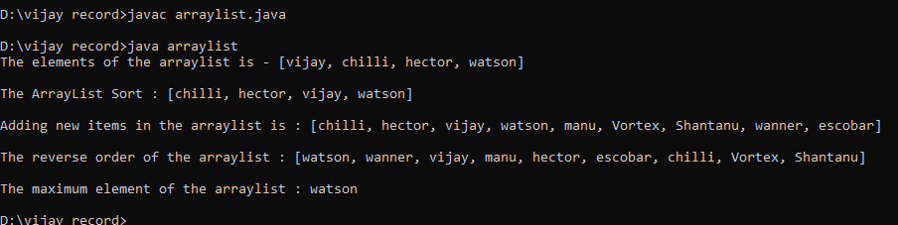

**Name: Vijay vishnu p b**

**Roll No:49**

**Batch:mca b**

**Date:7-06-2022**

**OBJECT ORIENTED PROGRAMMING LAB**

**Experiment No.: 23**

**Aim**

Program to demonstrate the creation of queue object using the Priority Queue class.

**Procedure**

import java.util.*;

public class PriorityQueue1{

public static void main(String[] args) {

PriorityQueue<Integer> queue= new PriorityQueue<>();

Scanner sc= new Scanner(System.in);

boolean iscontinue= true;

int choice;

while(iscontinue){

System.out.println("\nFollowing are the operations that you can perform on a PriorityQueue:\n1. Insertion.\n2. Deletion.\n3. Display the top element (peek).\n4. Exit");

System.out.print("Select your choice: ");

choice= sc.nextInt();

switch(choice){ case 1: {

System.out.print("\nEnter the element to insert: ");

queue.add(sc.nextInt());

break; }case 2: {

if(queue.size() <= 0)

System.out.println("\nCannot delete from the queue !! Queue is empty!!");

else

System.out.println("The deleted element is : "+queue.poll());

break; }

case 3: {

if(queue.size() <= 0)

System.out.println("\nCannot delete from the queue !! Queue is empty!!");

else System.out.println("The top element (peek) is : "+queue.peek());

break; }

case 4: {

iscontinue= false;

break; }

default:{ System.out.println("\nInvalid choice !! Please try again !!"

} }}

sc.close();

}}

**Output Screenshot**

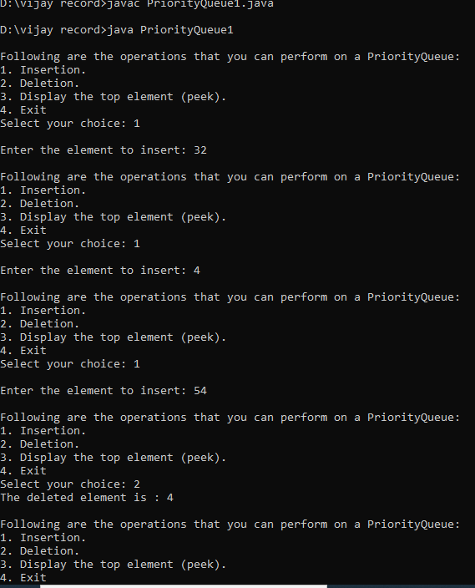

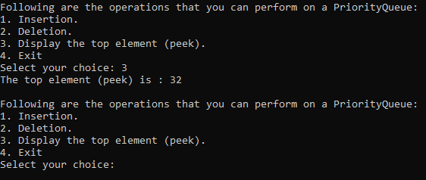

**Name: Vijay vishnu p b**

**Roll No:49**

**Batch:mca b**

**Date:7-06-2022**

**OBJECT ORIENTED PROGRAMMING LAB**

**Experiment No.: 24**

**Aim**

Program to demonstrate the addition and deletion of elements in deque.

**Procedure**

import java.util.*;

public class deque

{

public static void main(String[] args)

{

Deque<String> deque = new LinkedList<String>();

deque.add("vijay");

deque.addFirst("vortex");

deque.addLast("michle");

deque.push("hector");

deque.offer("aurther");

deque.offerFirst("henry");

System.out.println(deque + "\n");

deque.removeFirst();

deque.removeLast();

System.out.println("Deque after removing " + "first and last: " + deque);

}

}

**Output Screenshot**

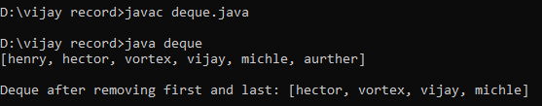

**Name: Vijay vishnu p b**

**Roll No:49**

**Batch:mca b**

**Date:7-06-2022**

**OBJECT ORIENTED PROGRAMMING LAB**

**Experiment No.: 25**

**Aim**

Write a Java program to compare two hash set.

**Procedure**

import java.util.*;

public class Hash{

public static void main(String[] args) {

HashSet<Integer> hash1= new HashSet<>();

hash1.add(2);

hash1.add(16);

hash1.add(44);

hash1.add(49);

hash1.add(19);

System.out.println("\nHashset a : ");

Iterator<Integer> ite1=hash1.iterator();

while(ite1.hasNext())

System.out.println(ite1.next());

HashSet<Integer> hash2= new HashSet<>();

hash2.add(16);

hash2.add(44);

hash2.add(10);

hash2.add(12);

hash2.add(75);

System.out.println("\nHashset b : ");

Iterator<Integer> ite2=hash2.iterator();

while(ite2.hasNext())

System.out.println(ite2.next());

System.out.println("\nElements that are common in both of the hashset are : ");

for(Integer elem: hash1){

if(hash2.contains(elem))

System.out.print(elem+"=> ");

}

System.out.println("\n");

}

}

**Output Screenshot**

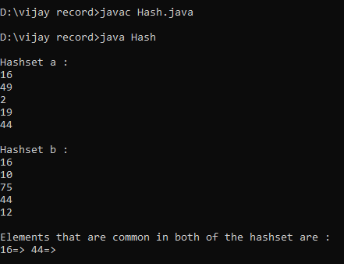

**Name: Vijay vishnu p b**

**Roll No:49**

**Batch:mca b**

**Date:7-06-2022**

**OBJECT ORIENTED PROGRAMMING LAB**

**Experiment No.: 26**

**Aim**

Program to demonstrate the working of Map interface by adding, changing and removing elements.

**Procedure**

import java.util.*;

public class hm {

public static void main(String[] args) {

Map<Integer, String> map= new HashMap<>();

Scanner sc= new Scanner(System.in);

int choice;

boolean iscontinue=true;

int map_count=0;

while(iscontinue){

System.out.println("\nMap Operations that you can perform are:\n1. Adding an element.\n2. Changing an element.\n3. Deleting an element.\n4. Display all elements.\n5. Exit.");

System.out.print("\nEnter the choice: ");

choice= sc.nextInt();

switch(choice){

case 1: {

System.out.print("\nEnter the string value for new element: ");

String item= sc.nextLine()+ sc.nextLine();

map_count++;

map.put(map_count,item);

break;

}

case 2: {

if(map.size() <= 0){

System.out.println("\nCannot chnage any element !! The map is empty.");

}

else{

System.out.print("\nEnter the key value of the element that you want to change: ");

int key= sc.nextInt();

boolean iskeyvalid= false;

for(Map.Entry<Integer, String> item: map.entrySet()){

if(key==item.getKey()){

System.out.print("\nEnter the new element to update from the map: ");

String value= sc.nextLine()+ sc.nextLine();

map.put(key,value);

iskeyvalid= true;

break;

}

}

if(!iskeyvalid){

System.out.println("\nInvalid key value !! Please enter an existing key value.");

}

}

break;

}

case 3: {

if(map.size() <= 0){

System.out.println("\nCannot delete any element !! The map is empty.");

}

else{

System.out.print("\nEnter the key value of the element that you want to delete: ");

int key= sc.nextInt();

boolean iskeyvalid= false;

for(Map.Entry<Integer, String> item: map.entrySet()){

if(key==item.getKey()){

iskeyvalid=true;

map.remove(key);

System.out.println("\nThe mentioned element is successfully deleted.");

break;

}

}

if(!iskeyvalid)

System.out.println("\nInvalid key value !! Please enter an existing key value.");

}

break;

}

case 4: {

if(map.size() <= 0){

System.out.println("\nCannot display any elements !! The map is empty.");

}

else{

System.out.println("\nThe elements in the map are : ");

for(Map.Entry<Integer, String> item: map.entrySet())

System.out.println("\nItem Key- "+item.getKey()+" & Item Value- "+item.getValue());

}

break;

}

case 5: {

iscontinue= false;

break;

}

default:{

System.out.println("\nInvalid choice !! Please try again !!");

}

}

}

sc.close();

}

}

**Output Screenshot**

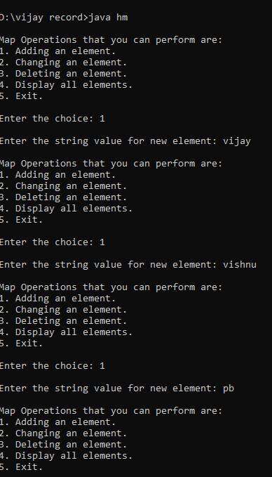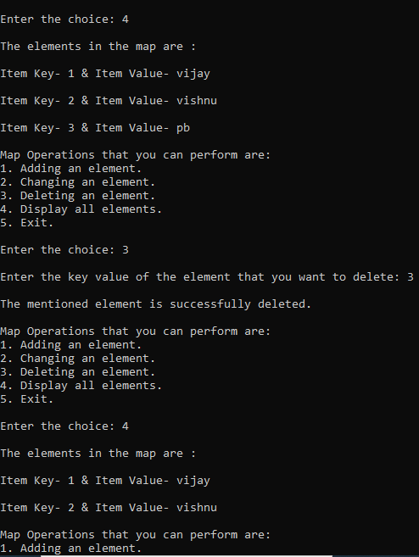

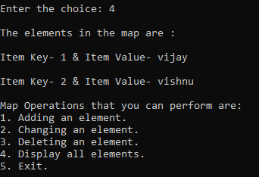

**Name: Vijay vishnu p b**

**Roll No:49**

**Batch:mca b**

**Date:9-06-2022**

**OBJECT ORIENTED PROGRAMMING LAB**

**Experiment No.: 27**

**Aim**

Program to find maximum of three numbers using AWT.

**Procedure**

import java.awt.*;

import java.awt.event.*;

public class largenum implements ActionListener{

Frame f=new Frame();

Label l1=new Label("First Number");

Label l2=new Label("Second Number");

Label l3=new Label("Third Number");

Label res=new Label("Result");

TextField t1=new TextField();

TextField t2=new TextField();

TextField t3=new TextField();

Button b1=new Button("Largest !");

largenum(){

l1.setBounds(50,100,100,20);

l2.setBounds(50,140,100,20);

l3.setBounds(50,180,100,20);

t1.setBounds(150,100,100,20);

t2.setBounds(150,140,100,20);

t3.setBounds(150,180,100,20);

b1.setBounds(50,220,100,20);

res.setBounds(50,260,100,20);

f.add(l1);

f.add(l2);

f.add(l3);

f.add(t1);

f.add(t2);

f.add(t3);

f.add(res);

f.add(b1);

b1.addActionListener(this);

f.setLayout(null);

f.setVisible(true);

f.setSize(400,400);

}

public static void main(String[] args){

new largenum();

}

public void actionPerformed(ActionEvent e){

if(e.getSource()==b1){

int n1=Integer.parseInt(t1.getText());

int n2=Integer.parseInt(t2.getText());

int n3=Integer.parseInt(t3.getText());

int largeres= (n1 > n2) ? (n1 > n3 ? n1 : n3) : (n2 > n3 ? n2 : n3);

res.setText(String.valueOf(largeres)+" is the largest");

}

}

}

**Output Screenshot**

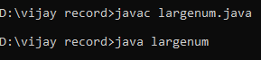

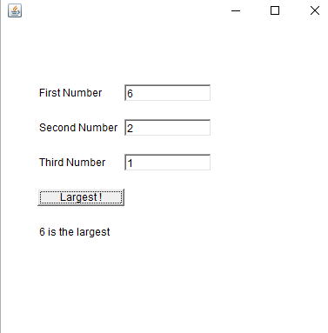

**Name: Vijay vishnu p b**

**Roll No:49**

**Batch:mca b**

**Date:9-06-2022**

**OBJECT ORIENTED PROGRAMMING LAB**

**Experiment No.: 28**

**Aim**

Implement a simple calculator using AWT components.

**Procedure**

import java.awt.*;

import java.awt.event.*;

public class Calculator implements ActionListener

{

Frame f=new Frame();

Label l1=new Label("First Number");

Label l2=new Label("Second Number");

Label l3=new Label("Result");

TextField t1=new TextField();

TextField t2=new TextField();

TextField t3=new TextField();

Button b1=new Button("Add");

Button b2=new Button("Sub");

Button b3=new Button("Mul");

Button b4=new Button("Div");

Button b5=new Button("Cancel");

Calculator()

{

l1.setBounds(50,100,100,20);

l2.setBounds(50,140,100,20);

l3.setBounds(50,180,100,20);

t1.setBounds(200,100,100,20);

t2.setBounds(200,140,100,20);

t3.setBounds(200,180,100,20);

b1.setBounds(50,250,50,20);

b2.setBounds(110,250,50,20);

b3.setBounds(170,250,50,20);

b4.setBounds(230,250,50,20);

b5.setBounds(290,250,50,20);

f.add(l1);

f.add(l2);

f.add(l3);

f.add(t1);

f.add(t2);

f.add(t3);

f.add(b1);

f.add(b2);

f.add(b3);

f.add(b4);

f.add(b5);

b1.addActionListener(this);

b2.addActionListener(this);

b3.addActionListener(this);

b4.addActionListener(this);

b5.addActionListener(this);

f.setLayout(null);

f.setVisible(true);

f.setSize(400,350);

}

public void actionPerformed(ActionEvent e)

{

int n1=Integer.parseInt(t1.getText());

int n2=Integer.parseInt(t2.getText());

if(e.getSource()==b1)

{

t3.setText(String.valueOf(n1+n2));

}

if(e.getSource()==b2)

{

t3.setText(String.valueOf(n1-n2));

}

if(e.getSource()==b3)

{

t3.setText(String.valueOf(n1*n2));

}

if(e.getSource()==b4)

{

t3.setText(String.valueOf(n1/n2));

}

if(e.getSource()==b5)

{

System.exit(0);

}

}

public static void main(String...s)

{

new Calculator();

}

}

**Output Screenshot**

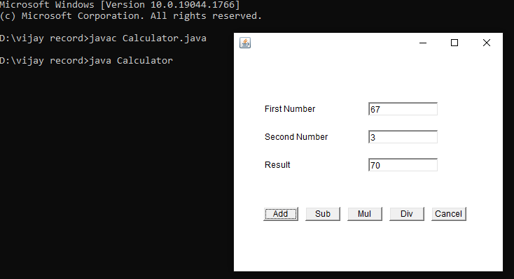

**Name: Vijay vishnu p b**

**Roll No:49**

**Batch:mca b**

**Date:9-06-2022**

**OBJECT ORIENTED PROGRAMMING LAB**

**Experiment No.: 29**

**Aim**

Develop a program to handle all mouse events and window events

**Procedure**

import java.awt.*;

import java.awt.event.*;

public class Mouseevents extends Frame implements MouseListener{

Label l;

Mouseevents(){

addMouseListener(this);

l=new Label();

l.setBounds(20,50,100,20);

add(l);

setSize(300,300);

setLayout(null);

setVisible(true);

}

public void mouseClicked(MouseEvent e) {

l.setText("Mouse Clicked");

}

public void mouseEntered(MouseEvent e) {

l.setText("Mouse Entered");

}

public void mouseExited(MouseEvent e) {

l.setText("Mouse Exited");

}

public void mousePressed(MouseEvent e) {

l.setText("Mouse Pressed");

}

public void mouseReleased(MouseEvent e) {

l.setText("Mouse Released");

}

public static void main(String[] args) {

new Mouseevents();

}

}

**Output Screenshot**

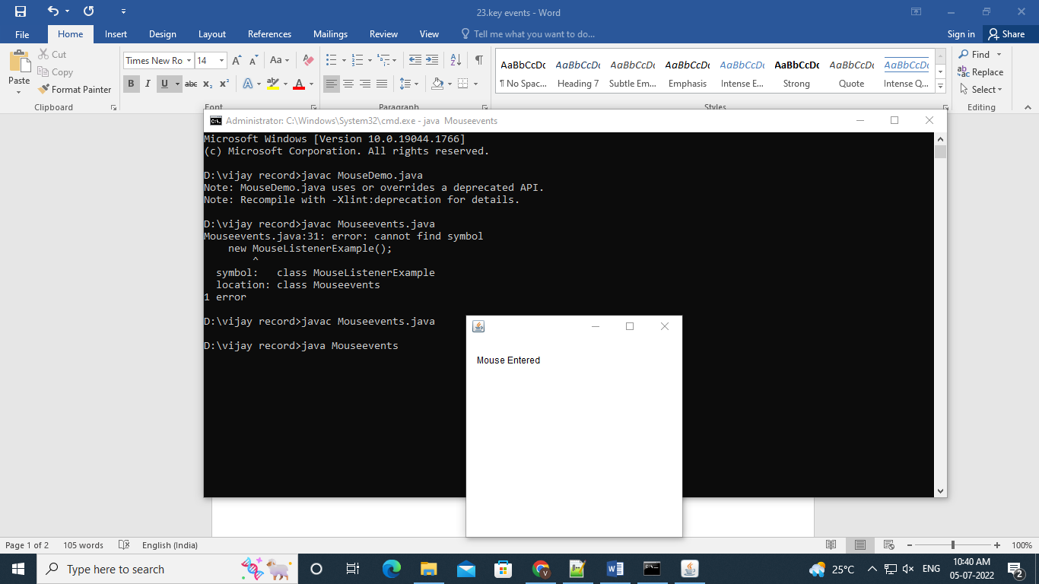

**Name: Vijay vishnu p b**

**Roll No:49**

**Batch:mca b**

**Date:9-06-2022**

**OBJECT ORIENTED PROGRAMMING LAB**

**Experiment No.: 30**

**Aim**

Develop a program to handle Key events.

**Procedure**

import java.awt.FlowLayout;

import java.awt.Frame;

import java.awt.Label;

import java.awt.TextField;

import java.awt.event.KeyEvent;

import java.awt.event.KeyListener;

public class KE implements KeyListener

{

Label lb1, lbl2, lb;

TextField tf1;

Frame fr;

String s;

KE()

{

fr = new Frame("KeyEventListener Example");

lb1= new Label(" Key Events will be displayed based on the actions", Label.CENTER);

lbl2= new Label();

lb= new Label();

tf1 = new TextField(20);

fr.setLayout(new FlowLayout());

fr.add(lb1);

fr.add(tf1);

fr.add(lbl2);

tf1.addKeyListener(this);

fr.setSize(460,250);

fr.setVisible(true);

}

public void keyPressed(KeyEvent ev)

{

lbl2.setText(" Key pressed");

}

public void keyReleased(KeyEvent ev)

{

lbl2.setText("Released");

}

public void keyTyped(KeyEvent ev)

{

lbl2.setText("Key is typed");

fr.setVisible(true);

}

public static void main(String[] args)

{

new KE();

}

}

**Output Screenshot**

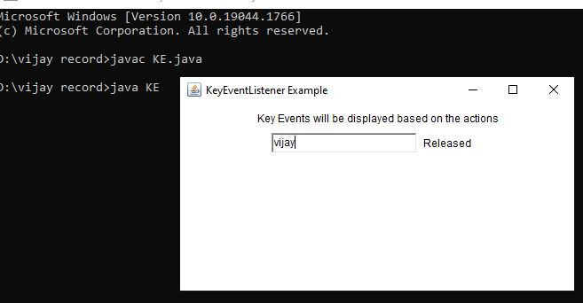

**Name: Vijay vishnu p b**

**Roll No:49**

**Batch:mca b**

**Date:31-05-2022**

**OBJECT ORIENTED PROGRAMMING LAB**

**Experiment No.: 31**

**Aim**

Write a program to write to a file, then read from the file and display the contents on the console

**Procedure**

import java.io.FileReader;

import java.io.FileWriter;

import java.io.IOException;

import java.io.*;

import java.util.*;

import java.io.File;

class read {

public static void main(String[] args) {

String var = "";

Scanner scan = new Scanner(System.in);

System.out.println("Enter the text to create file : type ENTER key 3 times to stop");

while (!var.endsWith("\n\n\n"))

var = var + scan.nextLine() + "\n";

try {

File file = new File("output.txt");

FileWriter fw = new FileWriter(file);

fw.write(var);

fw.close();

System.out.println("Reading File content");

FileReader fr = new FileReader("output.txt");

String str = "";

int i;

while ((i = fr.read()) != -1) {

str += (char) i;

}

System.out.println(str);

fr.close();

} catch (IOException e) {

System.out.println("There are some exception");

}

}

**Output Screenshot**

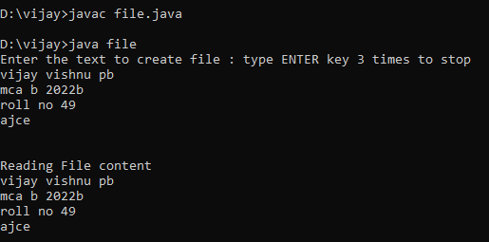

**Name: Vijay vishnu p b**

**Roll No:49**

**Batch:mca b**

**Date:31-05-2022**

**OBJECT ORIENTED PROGRAMMING LAB**

**Experiment No.: 32**

**Aim**

Write a program to copy one file to another.

**Procedure**

import java.io.FileInputStream;

import java.io.FileOutputStream;

import java.io.IOException;

public class CopyFile {

    public static void main(String[] args) throws IOException {

        FileInputStream fileinput = new FileInputStream("1.txt");

        FileOutputStream fileoutput = new FileOutputStream("2.txt");

        int i;

        while ((i = fileinput.read()) != -1) {

            fileoutput.write(i);

        }

        System.out.println("Successfully copied one file to another");

        fileinput.close();

        fileoutput.close();

    }

}

**Output Screenshot**

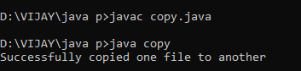

 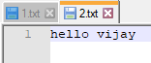

**Name: Vijay vishnu p b**

**Roll No:49**

**Batch:mca b**

**Date:31-05-2022**

**OBJECT ORIENTED PROGRAMMING LAB**

**Experiment No.: 33**

**Aim**

Write a program that reads from a file having integers. Copy even numbers and odd numbers to separate files.

**Procedure**

import java.io.FileInputStream;

import java.io.FileOutputStream;

import java.io.IOException;

public class Evenandodd

{

public static void main(String[] args) throws IOException {

FileInputStream source = new FileInputStream ("source.txt");

FileOutputStream destination_odd = new FileOutputStream ("odd.txt");

FileOutputStream destination_even = new FileOutputStream ("even.txt");

int i;

while((i = source.read()) != -1){

if(i%2==0) {

destination_even.write(i);

}

else {

destination_odd.write(i);

}

}

System.out.println("copied");

source.close();

destination_even.close();

destination_odd.close();

}

}

**Output Screenshot**

